Unit V
Game playing techniques like minimax procedure, alpha-beta cut-offs etc, Study of the block world problem in robotics.

Game Playing in Artificial Intelligence
Game Playing is an important domain of artificial intelligence. Games don’t require much knowledge; the only knowledge we need to provide is the rules, legal moves and the conditions of winning or losing the game. Both players try to win the game. So, both of them try to make the best move possible at each turn. Searching techniques like BFS (Breadth First Search) are not accurate for this as the branching factor is very high, so searching will take a lot of time. So, we need another search procedures that improve –
- Generate procedure so that only good moves are generated.
- Test procedure so that the best move can be explored first.

Game playing is a popular application of artificial intelligence that involves the development of computer programs to play games, such as chess, checkers, or Go. The goal of game playing in artificial intelligence is to develop algorithms that can learn how to play games and make decisions that will lead to winning outcomes.
- One of the earliest examples of successful game playing AI is the chess program Deep Blue, developed by IBM, which defeated the world champion Garry Kasparov in 1997. Since then, AI has been applied to a wide range of games, including two-player games, multiplayer games, and video games.
There are two main approaches to game playing in AI, rule-based systems and machine learning-based systems.
- Rule-based systems use a set of fixed rules to play the game.
- Machine learning-based systems use algorithms to learn from experience and make decisions based on that experience.

In recent years, machine learning-based systems have become increasingly popular, as they are able to learn from experience and improve over time, making them well-suited for complex games such as Go. For example, AlphaGo, developed by DeepMind, was the first machine learning-based system to defeat a world champion in the game of Go.

Game playing in AI is an active area of research and has many practical applications, including game development, education, and military training. By simulating game playing scenarios, AI algorithms can be used to develop more effective decision-making systems for real-world applications.
The most common search technique in game playing is minimax search procedure. It is depth-first depth-limited search procedure. It is used for games like chess and tic-tac-toe.

Minimax algorithm uses two functions –

MOVEGEN: It generates all the possible moves that can be generated from the current position.

STATIC EVALUATION: It returns a value depending upon the goodness from the viewpoint of two-player
This algorithm is a two player game, so we call the first player as PLAYER1 and second player as PLAYER2. The value of each node is backed-up from its children. For PLAYER1 the backed-up value is the maximum value of its children and for PLAYER2 the backed-up value is the minimum value of its children. It provides most promising move to PLAYER1, assuming that the PLAYER2 has make the best move. It is a recursive algorithm, as same procedure occurs at each level.
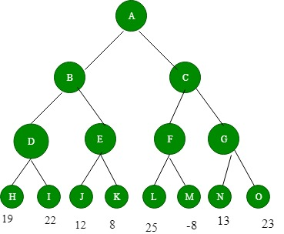
Figure 1: Before backing-up of values

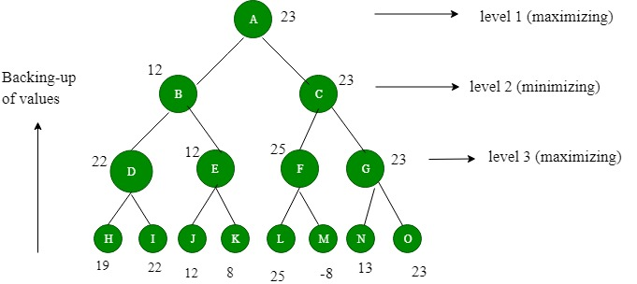
Figure 2: After backing-up of values We assume that PLAYER1 will start the game.
4 levels are generated. The value to nodes H, I, J, K, L, M, N, O is provided by STATICEVALUATION function. Level 3 is maximizing level, so all nodes of level 3 will take maximum values of their children. Level 2 is minimizing level, so all its nodes will take minimum values of their children. This process continues. The value of A is 23. That means A should choose C move to win.

The steps for the min max algorithm in AI can be stated as follows:
- Create the entire game tree.
- Evaluate the scores for the leaf nodes based on the evaluation function.
- Backtrack from the leaf to the root nodes:
For Maximizer, choose the node with the maximum score.
For Minimizer, choose the node with the minimum score.
- At the root node, choose the node with the maximum value and select the respective move.

Properties of min max algorithm in AI
- The algorithm is complete, meaning in a finite search tree, a solution will be certainly found.
- It is optimal if both the players are playing optimally.
- Due to Depth-First Search (DFS) for the game tree, the time complexity of the algorithm is O(b^ m), where b is the branching factor and m is the maximum depth of the tree.
- Like DFS, the space complexity of this algorithm is O(bm).

Limitations
- Because of the huge branching factor, the process of reaching the goal is slower.
- Evaluation and search of all possible nodes and branches degrades the performance and efficiency of the engine.
- Both the players have too many choices to decide from.
- If there is a restriction of time and space, it is not possible to explore the entire tree.
But with Alpha-Beta Pruning, the algorithm can be improved.

Advantages of Game Playing in Artificial Intelligence:
- Advancement of AI: Game playing has been a driving force behind the development of artificial intelligence and has led to the creation of new algorithms and techniques that can be applied to other areas of AI.
- Education and training: Game playing can be used to teach AI techniques and algorithms to students and professionals, as well as to provide training for military and emergency response personnel.
- Research: Game playing is an active area of research in AI and provides an opportunity to study and develop new techniques for decision-making and problem-solving.
- Real-world applications: The techniques and algorithms developed for game playing can be applied to real-world applications, such as robotics, autonomous systems, and decision support systems.

Disadvantages of Game Playing in Artificial Intelligence:
- Limited scope: The techniques and algorithms developed for game playing may not be well-suited for other types of applications and may need to be adapted or modified for different domains.
- Computational cost: Game playing can be computationally expensive, especially for complex games such as chess or Go, and may require powerful computers to achieve real-time performance.

1. How does the min-max algorithm work?
There are two participants in the AI min max algorithm: Maximiser and Minimizer. Both of these players compete in the game, with one attempting to achieve the highest score or maximum benefit and the other attempting to achieve the lowest score or minimum benefit. Because each game board includes an assessment score, the Maximiser will choose the highest value, while the Minimizer will choose the lowest value with counter movements. When the Maximiser does have the upper hand, the board score will be positive, but when the Minimizer seems to have the upper hand, the board score will be negative.

2. What are the properties of min max algorithm in AI?
The algorithm is complete, which means that a solution will almost certainly be discovered in a finite search tree. It is ideal if both players are performing at their best. The temporal complexity of the algorithm for the game tree is O(bm), in which b is the branching factor & m is the maximum depth of the tree, due to Depth-First Search (DFS). This algorithm, like DFS, has a space complexity of O(bm).

3. What are the limitations of minimax algorithm?
The process of obtaining the goal is slower due to the large branching factor. The engine's performance and efficiency suffer as a result of evaluating and searching all conceivable nodes and branches. Both players have an excessive number of options from which to choose. It is impossible to investigate the complete tree if there is a time and space constraint. The algorithm, however, can be enhanced by Alpha-Beta Pruning.

Alpha-Beta Pruning

- Alpha-beta pruning is a modified version of the minimax algorithm. It is an optimization technique for the minimax algorithm.

- As we have seen in the minimax search algorithm that the number of game states it has to examine are exponential in depth of the tree. Since we cannot eliminate the exponent, but we can cut it to half. Hence there is a technique by which without checking each node of the game tree we can compute the correct minimax decision, and this technique is called pruning. This involves two threshold parameter Alpha and beta for future expansion, so it is called alpha-beta pruning. It is also called as Alpha-Beta Algorithm.

- Alpha-beta pruning can be applied at any depth of a tree, and sometimes it not only prune the tree leaves but also entire sub-tree.

- The two-parameter can be defined as:
  - Alpha: The best (highest-value) choice we have found so far at any point along the path of Maximizer. The initial value of alpha is -∞.
  - Beta: The best (lowest-value) choice we have found so far at any point along the path of Minimizer. The initial value of beta is +∞.

- The Alpha-beta pruning to a standard minimax algorithm returns the same move as the standard algorithm does, but it removes all the nodes which are not really affecting the final decision but making algorithm slow. Hence by pruning these nodes, it makes the algorithm fast.

- The condition for Alpha-beta Pruning is that α >= β.

Key points about alpha-beta pruning:
- The Max player will only update the value of alpha.
- The Min player will only update the value of beta.
- While backtracking the tree, the node values will be passed to upper nodes instead of values of alpha and beta.
- We will only pass the alpha, beta values to the child nodes.

Working of Alpha-Beta Pruning:
Let's take an example of two-player search tree to understand the working of Alpha-beta pruning
Step 1: At the first step the, Max player will start first move from node A where α= -∞ and β= +∞, these value of alpha and beta passed down to node B where again α= -∞ and β= +∞, and Node B passes the same value to its child D.
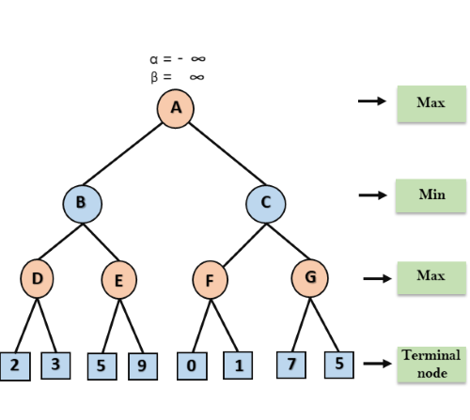
Step 2: At Node D, the value of α will be calculated as its turn for Max. The value of α is compared with firstly 2 and then 3, and the max (2, 3) = 3 will be the value of α at node D and node value will also 3.
Step 3: Now algorithm backtrack to node B, where the value of β will change as this is a turn of Min, Now β= +∞, will compare with the available subsequent nodes value, i.e. min (∞, 3) = 3, hence at node B now α= -∞, and β= 3.
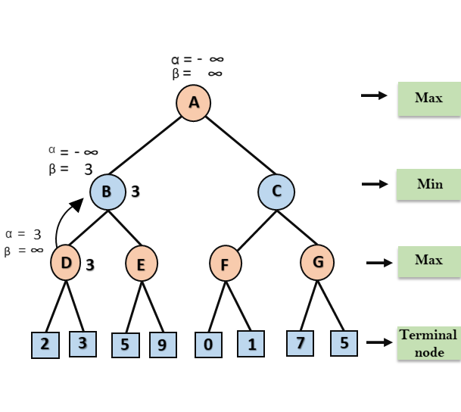
In the next step, algorithm traverse the next successor of Node B which is node E, and the values of α= -∞, and β= 3 will also be passed.
Step 4: At node E, Max will take its turn, and the value of alpha will change. The current value of alpha will be compared with 5, so max (-∞, 5) = 5, hence at node E α= 5 and β= 3, where α>=β, so the right successor of E will be pruned, and algorithm will not traverse it, and the value at node E will be 5.
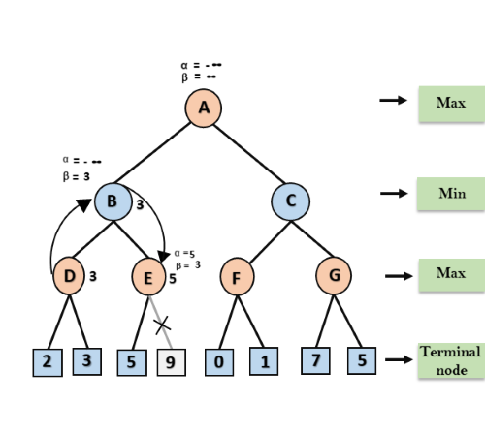
Step 5: At next step, algorithm again backtrack the tree, from node B to node A. At node A, the value of alpha will be changed the maximum available value is 3 as max (-∞, 3)= 3, and β= +∞, these two values now passes to right successor of A which is Node C.

At node C, α=3 and β= +∞, and the same values will be passed on to node F.

Step 6: At node F, again the value of α will be compared with left child which is 0, and max(3,0)= 3, and then compared with right child which is 1, and max(3,1)= 3 still α remains 3, but the node value of F will become 1.
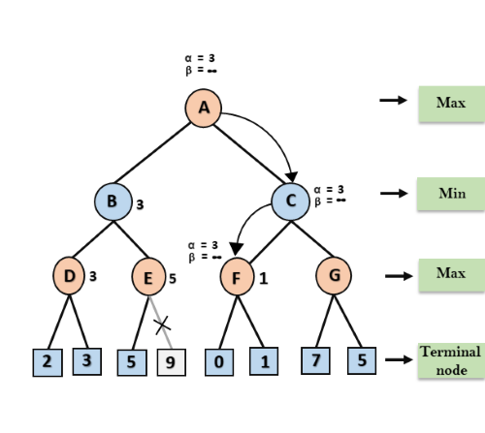
Step 7: Node F returns the node value 1 to node C, at C α= 3 and β= +∞, here the value of beta will be changed, it will compare with 1 so min (∞, 1) = 1. Now at C, α=3 and β= 1, and again it satisfies the condition α>=β, so the next child of C which is G will be pruned, and the algorithm will not compute the entire sub-tree G.
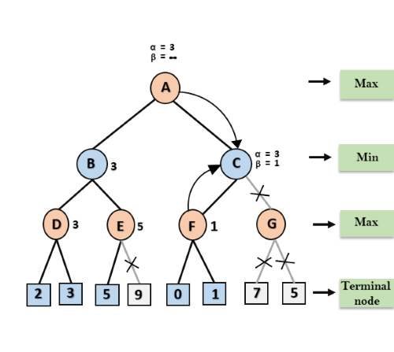
Step 8: C now returns the value of 1 to A here the best value for A is max (3, 1) = 3. Following is the final game tree which is the showing the nodes which are computed and nodes which has never computed. Hence the optimal value for the maximizer is 3 for this example.
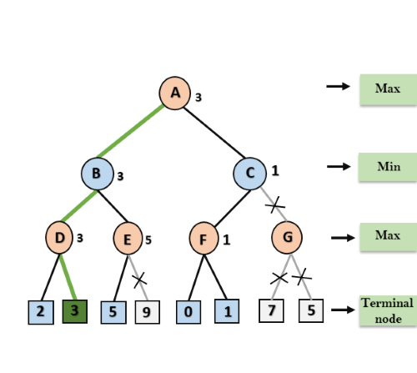

Move Ordering in Alpha-Beta pruning:
The effectiveness of alpha-beta pruning is highly dependent on the order in which each node is examined. Move order is an important aspect of alpha-beta pruning.
It can be of two types:
- Worst ordering: In some cases, alpha-beta pruning algorithm does not prune any of the leaves of the tree, and works exactly as minimax algorithm. In this case, it also consumes more time because of alpha-beta factors, such a move of pruning is called worst ordering. In this case, the best move occurs on the right side of the tree. The time complexity for such an order is O(b^{m}).
- Ideal ordering: The ideal ordering for alpha-beta pruning occurs when lots of pruning happens in the tree, and best moves occur at the left side of the tree. We apply DFS hence it first search left of the tree and go deep twice as minimax algorithm in the same amount of time. Complexity in ideal ordering is O(b^{m/2}).

Rules to find good ordering:
Following are some rules to find good ordering in alpha-beta pruning:
- Occur the best move from the shallowest node.
- Order the nodes in the tree such that the best nodes are checked first.
- Use domain knowledge while finding the best move. Ex: for Chess, try order: captures first, then threats, then forward moves, backward moves.
- We can bookkeep the states, as there is a possibility that states may repeat.

What is Blocks World Problem?
This is how the problem goes — There is a table on which some blocks are placed. Some blocks may or may not be stacked on other blocks. We have a robot arm to pick up or put down the blocks. The robot arm can move only one block at a time, and no other block should be stacked on top of the block which is to be moved by the robot arm.
Our aim is to change the configuration of the blocks from the Initial State to the Goal State, both of which have been specified in the diagram above.

What is Goal Stack Planning?
Goal Stack Planning is one of the earliest methods in artificial intelligence in which we work backwards from the goal state to the initial state.
We start at the goal state and we try fulfilling the preconditions required to achieve the initial state. These preconditions in turn have their own set of preconditions, which are required to be satisfied first. We keep solving these “goals” and “sub-goals” until we finally arrive at the
Initial State. We make use of a stack to hold these goals that need to be fulfilled as well the actions that we need to perform for the same.
Apart from the “Initial State” and the “Goal State”, we maintain a “World State” configuration as well. Goal Stack uses this world state to work its way from Goal State to Initial State. World State on the other hand starts off as the Initial State and ends up being transformed into the Goal state.
At the end of this algorithm we are left with an empty stack and a set of actions which helps us navigate from the Initial State to the World State.

Representing the configurations as a list of “predicates”
Predicates can be thought of as a statement which helps us convey the information about a configuration in Blocks World.
Given below are the list of predicates as well as their intended meaning
- ON(A,B) : Block A is on B
- ONTABLE(A) : A is on table
- CLEAR(A) : Nothing is on top of A
- HOLDING(A) : Arm is holding A.
- ARMEMPTY : Arm is holding nothing
Using these predicates, we represent the Initial State and the Goal State in our example like this:
Initial State — ON(B,A) ∧ ONTABLE(A) ∧ ONTABLE(C) ∧ ONTABLE(D) ∧ CLEAR(B) ∧ CLEAR(C) ∧ CLEAR(D) ∧ ARMEMPTY
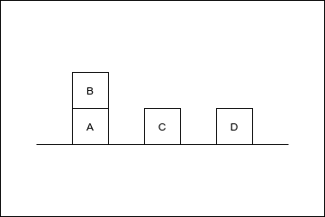
Initial State
Goal State — ON(C,A) ∧ ON(B,D) ∧ ONTABLE(A) ∧ ONTABLE(D) ∧ CLEAR(B) ∧ CLEAR(C) ∧ ARMEMPTY
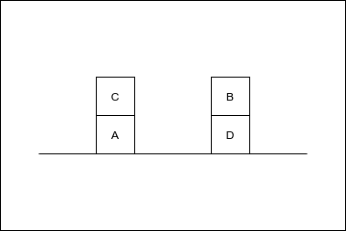
Goal State
Thus a configuration can be thought of as a list of predicates describing the current scenario.
“Operations” performed by the robot arm
The Robot Arm can perform 4 operations:
- STACK(X,Y) : Stacking Block X on Block Y
- UNSTACK(X,Y) : Picking up Block X which is on top of Block Y
- PICKUP(X) : Picking up Block X which is on top of the table
- PUTDOWN(X) : Put Block X on the table
All the four operations have certain preconditions which need to be satisfied to perform the same. These preconditions are represented in the form of predicates.
The effect of these operations is represented using two lists ADD and DELETE. DELETE List contains the predicates which will cease to be true once the operation is performed. ADD List on the other hand contains the predicates which will become true once the operation is performed.
The Precondition, Add and Delete List for each operation is rather intuitive and have been listed below.
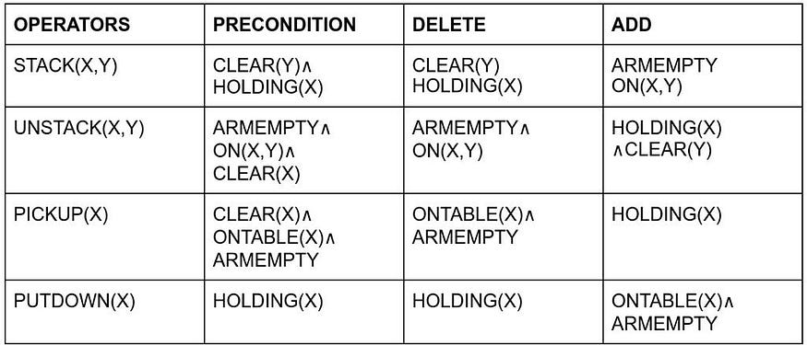
Operations performed by the Robot Arm
For example, to perform the STACK(X,Y) operation i.e. to Stack Block X on top of Block Y, No other block should be on top of Y (CLEAR(Y)) and the Robot Arm should be holding the Block X (HOLDING(X)).
Once the operation is performed, these predicates will cease to be true, thus they are included in DELETE List as well. (Note : It is not necessary for the Precondition and DELETE List to be the exact same).
On the other hand, once the operation is performed, The robot arm will be free (ARMEMPTY) and the block X will be on top of Y (ON(X,Y)).
The other 3 Operators follow similar logic, and this part is the cornerstone of Goal Stack Planning.

